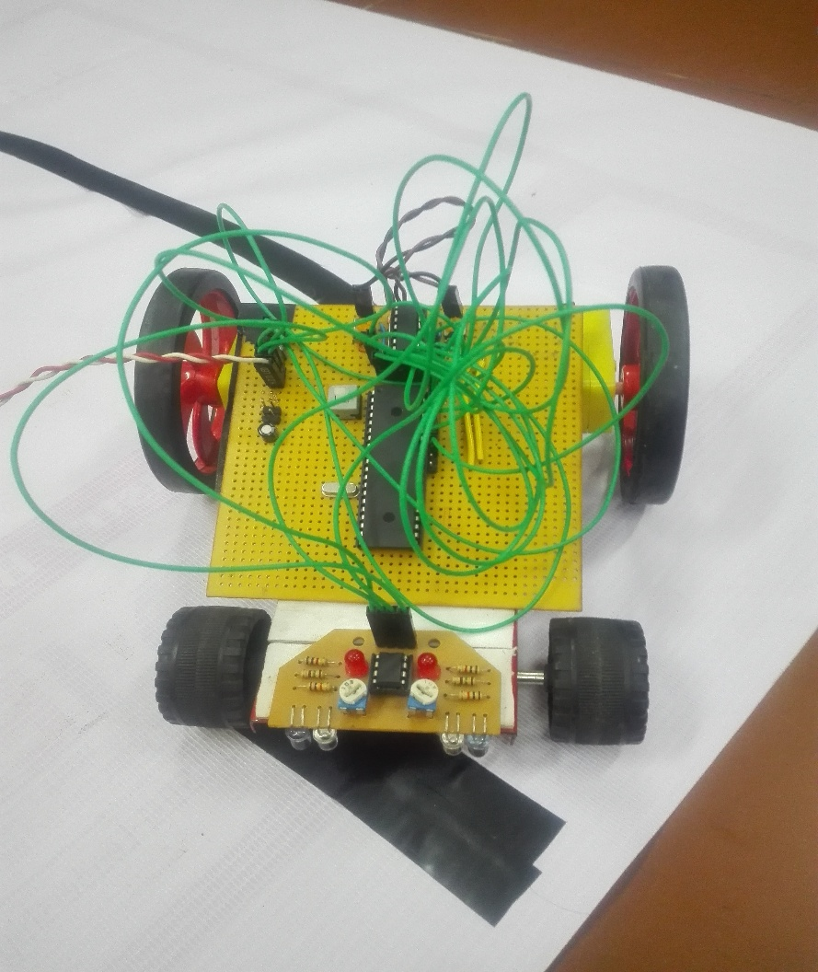

Maze Runner

An Autonomous Line Maze Solver

Project By:

Guru Prasath. G, II ECE A

Dhinesh Kumar. P, II ECE A

Maze Runner

An Autonomous Line Maze Solver

# Abstract

Line Maze solving robots are ideal projects to do for anyone who is entering the domain to embedded systems. And it’s the very reason we chose to do this. The robot has Microchip© PIC© Microcontroller as it core, and uses IR sensor as input and a motor drive for its output. We made the robot as modular as possible, as we have planned to interface other kind of inputs and outputs to its core, like a hovering motor to make it a hover bot.